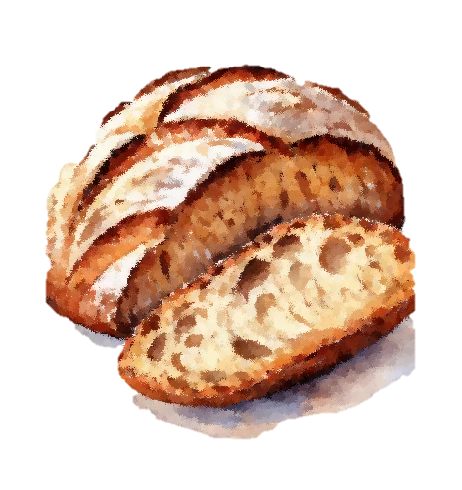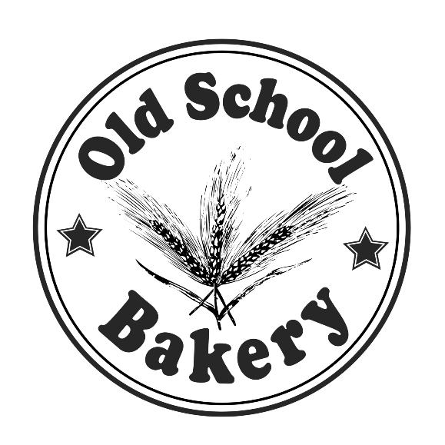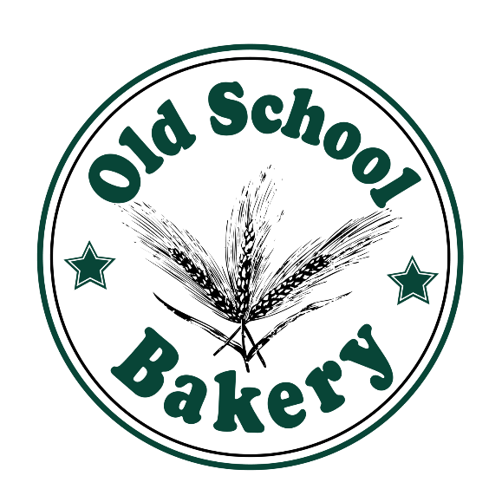

Use Promocode ux125x to get 10% discount

Sourdough Bread

**4.99$**

**1.99$**

Raspberry Cupcakes

CONTACT US

Email: oldSchoolBakery@plpsd.ca

www.oldSchoolbakery.ca

**WHY CHOOSE US?**

* **We’re affordable**
* **We’re near by**
* **We have quality products**

Best Cake in Town

CAKE

Delicious